**5. COMPONENT DESIGN**

**Member Registration**

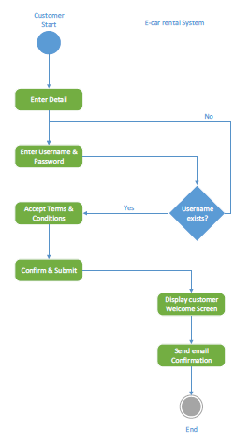

**Profile Modification**

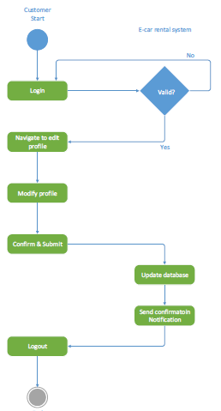

**Reservation of Car**

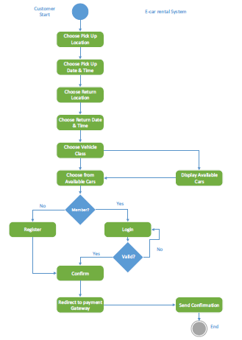

**Adding a New Car**

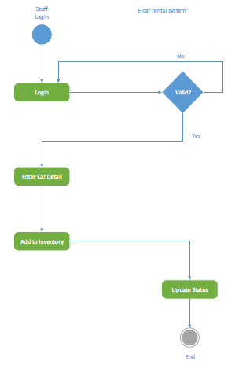

**6. HUMAN INTERFACE DESIGN**

**6.1 Overview of User Interface**

Based on the user’s perspective, upon accessing the website they will see the home page, where they can see an announcement, recommended vehicles, a newsletter and a miniature “about us” menu with several selections (newsletter and ‘about us’ miniature menu shall be the footer, visible on all other pages). They will be able to browse all pages, such as ‘Car Listings’, ’About Us’, ‘FAQ’, ‘Contact Us’ (this will be the header, visible on all pages, along with the website logo, login button and other information). Everyone starts as a guest-type user, and because this is a car rental service website, they must click on the “login/register” button to be able to use the full functionalities of the website. Of course, guest-type users are still able to view most of the website and even subscribe to the newsletter and utilize the ‘Contact us’ page, where they can contact the administrator. Newsletter subscription requires that they enter an email address.

Unsuccessful registrations/logins will lead to a warning. Failing to complete mandatory fields will also lead to a warning. Once logged in, the user will be able to book the vehicles listed in the ‘Car Listings’ page. This page is equipped with a search function which contains categories such as vehicle brand and fuel type. It also contains a list of recently listed vehicles. The logged user can select any vehicle and view the details about it. An overview, registered year, fuel type, seats, rental price and a list of accessories are available for all to see. Here, the booking function is also available. The user must enter the booking period (From <Date>, To <Date>) and a short message regarding their request. If successful, the user will be alerted by a message. Then, they can access their user profile located in the drop-down menu where their username is displayed in the header and check their bookings and their status. They must then wait for the administrator’s approval. On a side note, in this drop-down menu, the user can also customize their personal information, update their password, send a testimonial to the administrator, view them and finally, sign out.

User interface share following qualities or characteristics:

**Clarity**: The interface avoids ambiguity by making everything clear through language, flow, hierarchy and metaphors for visual elements.

**Responsiveness**: This means a couple of things. First, responsiveness means speed: a good interface should not feel sluggish. Secondly, the interface should provide good feedback to the user about what’s happening and whether the user’s input is being successfully processed.

**Aesthetics**: While you don’t need to make an interface attractive for it to do its job, making something look good will make the time your users spend using your application more enjoyable; and happier users can only be a good thing.

**Efficiency**: Time is money, and a great interface should make the user more productive through shortcuts and good design.

**6.2 Screen Images**

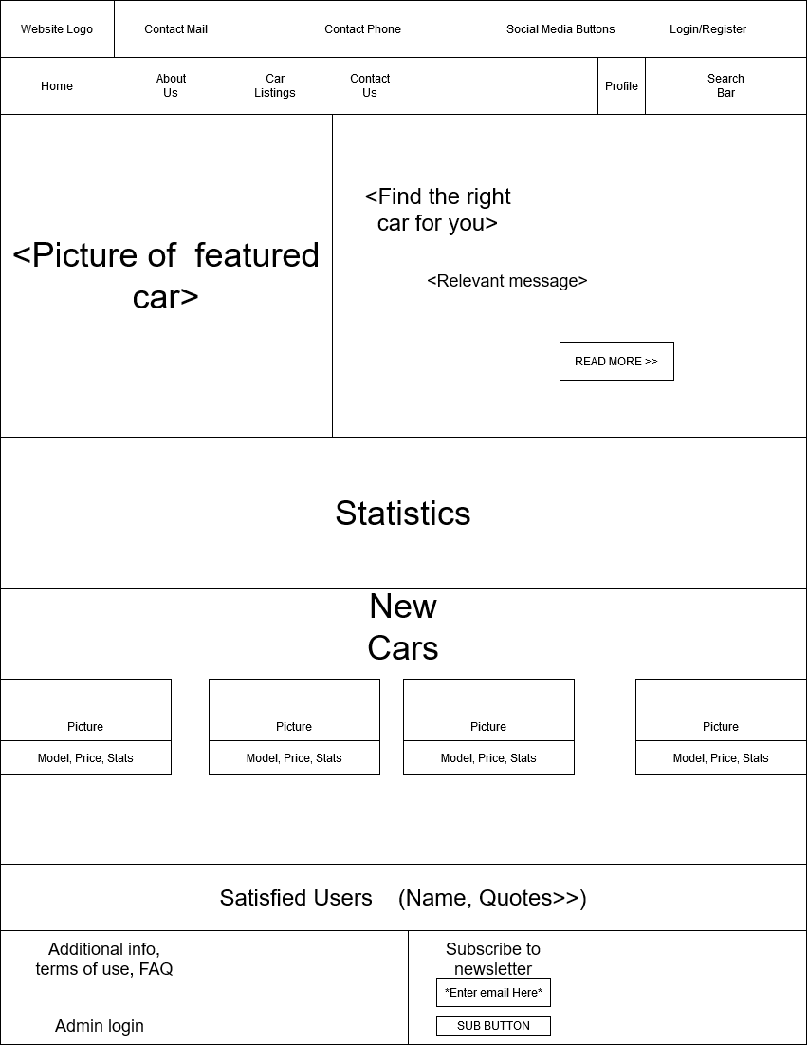

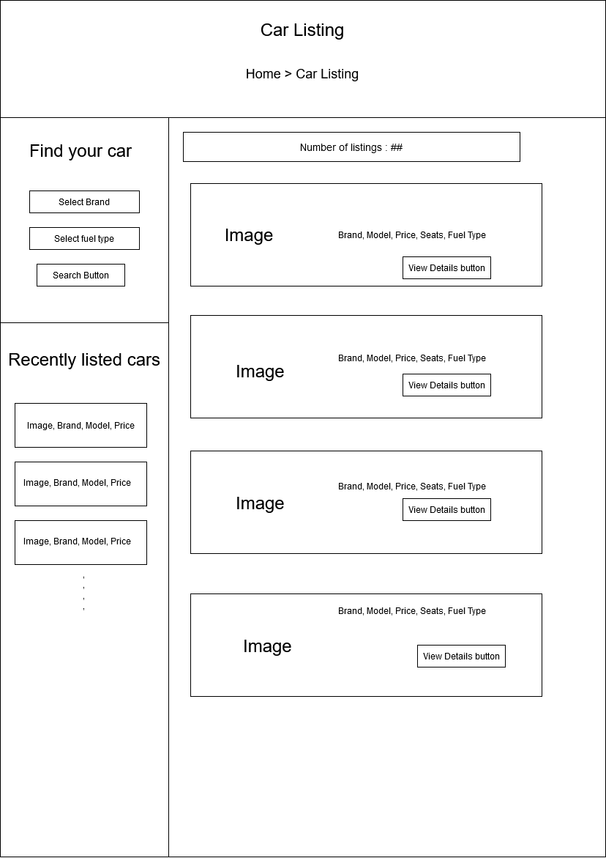

**6.3 Screen Objects and Actions**

Interface elements include:

* **Input Controls**: dropdown lists, list boxes, buttons, toggles(carousel), text fields
* **Navigational Components**: breadcrumb, slider, search field, pagination, icons
* **Informational Components**: tooltips, icons, notifications, message boxes, modal windows
* **Containers**: accordion